Phonics and Early Reading Policy
Scheme: Read Write Inc

Policy Written By: Rosie Rees
Policy Reviewed: June 2022
Review Date: June 2023
Policy: Curriculum and EYFS
Governors: No
1. Intent

At Finlay Community School, we strive to ensure that all children become successful, fluent readers by the end of Key Stage One and believe this is achievable through a combination of strong, high quality, discrete phonics teaching combined with a whole language approach that promotes a ‘Reading for Pleasure’ culture.
As learners in our school, our children:
- Use the skills of segmenting and blending to read words.
- Have the opportunity to engage in a variety of activities that will support and develop their learning and skills.
- Become fluent and confident readers by applying their phonics knowledge learnt through each set of sounds.
- Use and apply their phonics knowledge in other curriculum subjects when reading, spelling and writing.

1.2 Theory behind our Intent:
The Rose Report (2006) emphasised high quality phonics as an important part of the word decoding skills required by children to develop higher level whole language and comprehension skills. This approach is in alignment with our belief that we first ‘learn to read’ and then ‘read to learn’.
Bold Beginnings November 2017 stated that “All primary schools should: make sure that the teaching of reading, including systematic synthetic phonics, is the core purpose of the Reception Year.”
The Reading Framework: teaching for foundations of literacy states (2022) “Close and regular assessment of children as they learn to read is vital if teaching is to match their capacity to learn and if difficulties are to be identified when they first arise, and overcome.”
This policy is aimed at reinforcing a consistent, high quality approach to the teaching of phonics across the Early Years Foundation Stage (EYFS), Key Stage One and on into Key Stage Two for children who still need this further support.

2. Implementation

At Finlay Community School, we use Read Write Inc scheme to engage our children in developing their phonics learning. Our principal aim is to develop the children’s phonological awareness, the ability to segment and blend words and read common exception words on sight. This will then help children to progress into becoming fluent readers and writers.

Our teaching at all levels includes a range of:
- Whole class teaching.
- Individual and group work.
- Small intervention groups.

2.1 Preschool
Phonics is taught in small groups for 20 minutes every day. Learning one sound a week. Set one (single Graphemes) of Read Write Inc programme is used to help children to gain good listening skills to aid their phonics learning. A wide range of activities and games should be used to engage children’s learning and to help them reach their full potential. The aim in Preschool is to complete set 1 before the children move into Reception.

2.2 Reception
Phonics is taught 5 times weekly for 30 – 45 minutes each from the start of the academic year. Children are to be split into ability groups and taught a sound for 5 days. The aim is to complete set 1 and 2 before the children reach Year 1 with the ability to segment and blend CVC / CCVC words, and recognise some tricky words. Towards the end of the summer term alien words are to be introduced ready for year 1.

2.3 Year 1

The Read, Write Inc programme is the sole programme used. Children in Year 1 have access to high quality daily phonics sessions for 40 - 50 minutes. Teaching 5 sounds a week. Groups are differentiated to ensure all children reach their full potential; teachers work with groups on a rotational basis to ensure high quality provision for all children. The underlying aim of Year 1 should be to ensure all children have completed set 1, 2 & 3 sounds from the Read, Write Inc programme. They should have plenty of practice in recognising ‘alien’ or pseudo words, in readiness for the Phonic Screening Check and to give them the confidence to read any word. Children should aim to read and write all the common exception words for Years 1 and 2.
NB: Phonics screening takes place in June - further details can be found below in National Phonics Screening.

  - Year 2
Phonics is taught every day for 40 - 50 minutes from the start of the academic year. The Read, Write Inc programme is the sole programme used. Teaching includes set 1,2 & 3 sounds. The aim is for:
- Children to be confident to read all of set 1, 2 and 3 sounds
- Children to become confident of alternative spelling patterns
- Children to be able to read with fluency
- Children to be able to read multi-syllabic words
In line with our intent guide and progression map, children who are working at Age Related Expectations should be signed off the RWI programme in spring term.

Once the children are off the programme, they will move onto whole class reading with a high quality text.

Groups are differentiated to ensure all children reach their full potential. Teachers work with groups on a rotational basis to ensure high quality provision for all children.

NB: Any children who did not pass the phonics screening test in Year 1 will retake the PSC in Year 2. Further details can be found below in National Phonics Screening.

  - Structure of a daily phonics lesson:

More information regarding the planning and teaching of each phonics lesson can be found in the RWI teacher planning guide, or lesson plans can be downloaded from the RWI portal.

Every lesson will begin with a speed sounds lesson. This includes:

2.51 Set 1 sounds:
Teach new sound
Say the sound
Read the sound
Review the sounds
Write the letter
Speed write – review of previous taught sounds.
Fred talk (oral)

2.52 Set 2/ 3 sounds:
Each lesson will begin with a speed sounds lesson. This includes:
Teach new sound
Say the sound
Read the sound
Review the sounds
Read the words with the new taught sound in.
Review the words from previous taught sounds.
Reading assessment with Alien words.
Spell with Fred fingers- 2 -3 words.
Spell review, children write words with previously taught sounds in – 2- 3 words.

2.53 Storybook/Reading within Phonics

After the children’s speed sound session, they will read a storybook, which is fully decodable. These are mapped out and progressive, with a range of stories per phonics set. These are organised in the phonics book cupboard, with book bag books placed alongside the decodable RWI storybook.

Day by day storybook sessions – 5-day timetable. Green colour book and above.

Day 1:
Phonics speeds sound lesson
Speed sounds from storybook. (Adult model)
Story green word cards (Adult model)
Speedy green words (Adult model)
Red words (Adult model)
Partner practise in storybooks (at tables)
Teacher will read the story introduction to the story – you can do this in a special book like trainer said to make it more interesting. (Children close their books).

Day 2:
Phonics speeds sound lesson
Speed sounds from storybook. (Adult model)
Story green word cards (Adult model)
Speedy green words (Adult model)
Red words (Adult model)
Partner practice in story books (at tables)
Adults read aloud with expression - no questions etc, just reading.
Children have first read – Fred talk (In head if they can).

.
Day 3:
Phonics speeds sound lesson
Speed sounds from storybook (partner practise – at tables) – Fred in Head.
Story green word cards (partner practise – at tables) - Fred in Head.
Speedy green words (partner practise – at tables) - Fred in Head.
Red words (partner practise – at tables) - Fred in Head.
Children have second read - Fred in Head.
Hold a sentence - from handbook.
Day 4:
Phonics speeds sound lesson
Story green word cards (partner practise – at tables) - Fred in head.
Speedy green words (partner practise – at tables) - Fred in head.
Red words (partner practise – at tables) - Fred in head.
Children have third read - Fred in Head with expression.
Think about the story - questions and think aloud.
Hold a sentence - from handbook.

Day 5:
Phonics speeds sound lesson
Speedy green words (partner practice) – Fred in head.
Children have fouth read - Fred in Head with expression.
Questions to talk about; these are in the RWI book.
Hold a sentence (Green onwards make up a decodable sentence about the book) (Yellow and above, write the answers to the questions – just 1 question).

  - Phonics Interventions

Pupil progress and attainment is monitored throughout the year. RWI assessments are completed half-termly, and YARC Reading Assessments are used termly, to monitor children’s reading rate, reading accuracy and comprehension. These assessments inform new groupings, but also inform the provision and intervention that is best suited for that pupil. The interventions below can be carried out by the Class Teacher, Teaching Assistant or the Academic Mentor.

In addition to the whole class teaching of phonics, we provide intervention programmes for children in EYFS and KS1 to ensure all children reach their full potential. Interventions are run in a variety of ways, including whole group teaching, games and activities. We also use the 1:1 RWI tutoring intervention, which is a small phonics session 1:1 with an adult looking at the gaps of that particular child. This includes: reviewing of sounds, reading of words with a particular sounds in, reading words containing previous sounds to gain confidence, reading alien words and developing reading fluency. The aim of these sessions is to enable pupils to gain confidence.

In KS2, Phonics is not explicitly taught daily but is referred to so that children can make connections between early Phonics learning and reading and spelling. The aim is that pupils in KS2 are able to decode words with increasing accuracy and fluency, and have a secure phonological awareness. Should a pupil not be working at Age Related Expectations, RWI or Rapid Reading would be used as an intervention.

Should children require additional intervention to RWI or Rapid Reading, precision teaching can be used following the advice of external agencies including speech and language, and the Advisory Teaching Service.

As children move throughout KS2, Spelling Shed is used to further develop children’s understanding of spelling patterns and alternative patterns for same sounds e.g. tion/sion

Lively, age-appropriate stories and texts are closely matched to children’s’ increasing knowledge of phonics and tricky words. Alongside reading, children are taught the English alphabetic code for spelling, vocabulary and grammar. They rapidly build up their spelling knowledge and are soon able to spell complex words confidently.

Children are introduced to a breadth of vocabulary in their reading, which soon leads to an adventurous choice of words in their writing. They rehearse aloud what they want to write, sentence-by-sentence until they are confident to write independently. The use of WAGOLLS helps children become exposed to high quality vocabulary.

2.7 Phonics Planning

Planning for phonics will be done separately (appendix 1 for planning template) from literacy but with the understanding that good phonics teaching should link to the literacy needs of the children within a literacy lesson and across the curriculum. Each Phonics lesson should include the following sections:
• Revise – Overlearn the previous graphemes and words.
• Teach – Introduce a new grapheme / phoneme words / tricky words.
• Practise – Develop GPCs (grapheme phoneme correspondences) /read and spell new words / tricky words.
• Apply – Use the new graphemes / words in games and activities to secure knowledge.
• Assess – Monitor progress within each phase to inform planning.
Phonics planning can be downloaded from the oxford owl website or we have the appropriate handbooks in school to support staff.
2.8 Classroom Environment
In the Early Years and KS1 each year group will have a Phonics display, concentrating on sounds and key words / tricky words that the children are currently learning. Every class to have a pocket chart / complex speed chart for revising sounds. Phonics mats are available in every lesson to support children’s early writing across the curriculum. KS2 will have phonics displays where necessary / if using the programme.

2.9 Reading scheme
Systematic synthetic phonics plays a key role in a rich and varied reading programme. The school has invested in a reading scheme to support children to apply their phonic knowledge and skills, as well as develop their reading comprehension. Reading books allow children to consolidate and apply their phonics knowledge. Reading books are matched to books that include graphemes and tricky words children have been taught. This makes it easy for teachers, parents and children to choose a text that is matched to the child’s growing phonic knowledge and that does not encourage a child to guess at words if they included sounds they had not yet been taught.
The children take home 3 books every week:
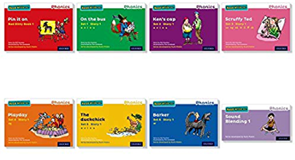
- The coloured storybook that they have been learning in school – this goes home after the children have read it in school to build children’s confidence.

- A book bag book – this is matched to the sounds the children have been taught but is a new text for them to read.

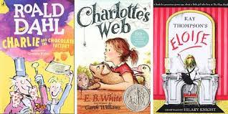
- A library book – a book for pleasure. This is what the parents read to their child / children.

If a child loses / damage books, we will ask for a contribution towards to the book so we can replace it.

2.10 Word boxes

Each child will be given a word box to take home .The children need to segment and blend the words. The word boxes will focus on a particular sound and the words associated to it. There are 47 word boxes. This is to encourage segmenting and blending. There are also Alien words to ready the children for phonics screening test. These will be started in summer term in reception and carry through to Year 1.

2.11 Phonics Training

We aim to ensure that all staff have up to date and current Phonics training. The role of the Phonics Lead is to ensure that everyone has the relevant training as well as making sure their own training is current and up to date. At Finlay we have purchased the Ruth Miskin’s Read Write Inc portal to ensure all staff have relevant up to date training and have a good quality resource to refer back to.

3. Impact

The impact of our curriculum can be measured and monitored in a variety of different ways. As a school, we use Target Tracker to monitor and measure progress in the core subjects: Maths, Writing, Reading and Science. Target Tracker allows all class teachers to colour code statements using three different colours: red indicates a child is Working Towards the statement, blue shows they are secure and gold shows they are working at Greater Depth within the standard. Target Tracker teacher judgement then allows subject leaders and the curriculum lead to cross-reference statements to evidence in books. At the end of each term (Autumn 1 and 2, Spring 1 and 2 and Summer 1 and 2), class teachers will assess pupils’ learning, by completing a data drop, indicating which level they feel the child is working at, backed up with the evidence they have colour coded. Subject leaders/ curriculum lead can then download progress reports to look at whether children are on track and making satisfactory/good progress. They are able to also look at attainment for different pupil groups.
3.1 Assessment
In the EYFS and KS1 we assess pupil progress on a Read Write Inc Phonics assessment sheets (Appendix 2) and plot the children on a Phonics tracker grid each half term (6-8 weeks). This shows
The phonics / reading lead or staff with leadership training in Read Write Inc are able to assess the children to ensure grouping is accurate.
The phonics and reading lead use an excel tracker grid and a grouping grid to ensure progression and if not, what is put in place to support these children such as interventions. This helps identify the lowest 20%. Throughout the year, Year 1 pupils will be given practice papers to identify specific skills or any gaps in learning. This will address what provision is put in place. This is shared with the English hub who currently supports up whilst we are implementing the RWI scheme.

3.2 National Phonics Screening

The National Phonics Screening takes place for all children in Year 1 in June. Only the Year 1 teacher or Phonics Lead can administer the test within school. If children fail to pass during Year 1, they will be expected to retake the test in Year 2. The data is submitted to the Local Authority.

3.3 The roles and responsibilities of the Phonics Lead include:

- To organise and order resources that are required
- To offer advice to teachers where required
- To encourage and lead training to staff
- To be aware of current developments in Phonics and update staff on these developments/changes
- To inform SLT and English Lead of changes and discuss any issues with them
- To monitor the standard of the teaching of Phonics through the school and support teachers where needed
- To monitor progress and results of the Phonics Screening Test in Year 1
- To monitor lesson planning
- To track progress across each phase
- Gain support from outer agencies such as: the English Hub
- Gain support from Read Write Inc Trainer
- Engage in development days with Read Write Inc Trainer
- Engage in remote progress meetings so ensure progress / correct groupings

3.4 The roles and responsibilities of the English Lead:

- To support and guide Phonics Lead where required.

(Please see What is Read Write Inc Guide for more support).

Written by: Rosie Rees - Phonics Lead
Supported by: -

Date: February 2022
Review date: February 2023.

Appendix 1- Phonics planning
This is an example of a lesson plan from set 1. This can be downloaded from oxford owl website or in the Read Write Inc handbook 1.

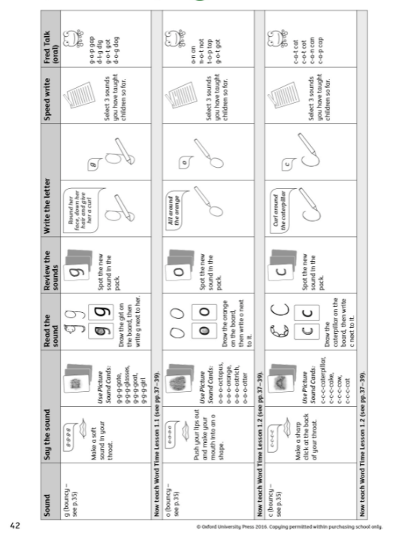

This planning maybe used for new staff / staff needing the steps broken down more to ensure quality teaching.

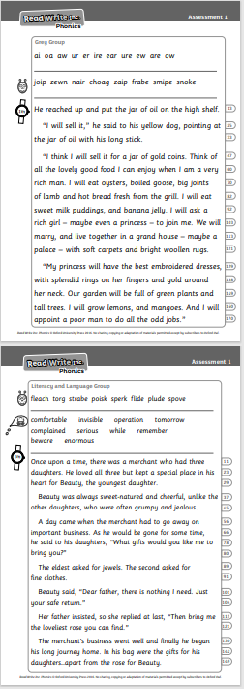
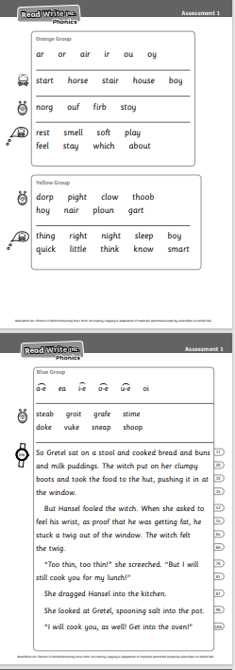
Appendix 2 – Phonics assessment sheet.
